

|  |
| --- |
| **SNR/PNR Automation Framework – White Paper**  Shardul Kaley, Assistant Manager – Quality Control  May 2016 |
|  |
|  |

**Version**

|  |  |  |  |
| --- | --- | --- | --- |
| **Date** | **Version** | **Author** | **Description** |
| May 07, 2016 | 1.0 | Shardul Kaley | Initial Draft |
| May 24, 2016 | 1.1 | Asma Doni | Reviewed and sent it to Beneficiary for updates |
| May 25, 2016 | 1.2 | Shardul Kaley | Updated and sent it to Asma Doni for review |
| May 26, 2016 | 1.3 | Asma Doni | Re-reviewed and completed |
| May 27, 2016 | 1.4 | Asma Doni | Added more updates in the document |
| Month DD, YYYY | 2.0 | Asma/Charudatt | Updated as per feedback and Completed |

**Reviewed By**

|  |  |
| --- | --- |
| **Date** | **Name** |
| May 24, 2016 | Asma Doni |
| Month DD, YYYY | Beneficiary’s Name |

# Introduction

Quality of a system can be assured only through an extensive testing process. This conscious understanding among the business and IT community has created a great demand for software testing. Testing starts with innovations, creativity and redefining with new dimensions. Many new testing methodologies, processes and quality road maps are created to exceed the expectations of the demands. Automation is one such dimension that helps us to migrate up the value-add chain with our customers. This paper is an attempt to identify the potential areas of automation and define a framework for efficient test automation. As the name describes, Salvage Non-Return and Product Non-Return (SNR/PNR) Automation Framework concentrates on modularizing the functionalities to the unit level and mapping them one after the other as per the script design flow. Any data handling process can be split into data initialization, data extraction, data validation and verification and finally data reporting.

# Why is SNR/PNR Automation Framework Needed?

### Problem 1: Test Data Variety

To validate the manual Salvage Non-Return and Product Non-Return (SNR/PNR), there were variety of test data needed to validate the changes deployed in QA and Production Environment. All needed test data to execute complex test scenarios was created manually earlier. The manual process of staging the data was very time consuming, cumbersome, and error prone. All these factors resulted into increase in test case execution timeframe, poor testing quality, and delayed final signoff. So to overcome this, we needed to automate the test data creation using the re-designed and automated SNR/PNR automation framework. Considering the complex and dynamic business rules, the framework should be configurable, easy to maintain, and extendable to accommodate the business requirements and changes. .The implementation of the SNR/PNR Automation Framework is based on industry standards open-source platform. This platform is customized in the most flexible format that enables configurations depending on the number and variety of test data sources.

### Problem 2: Database Integrity and Management

A business can evolve over time into different categories, geographies, and lines of business. All these developments of the automation database of SNR/PNR have a certain universal element to such business domain, which is called Master Automation Database, i.e., the test data required for validating business features (a list of all the features of an application is presented to the business/clients to selected the features based on their requirements, which is called Business Features)such as Payment Information, Auto payment of SNR/PNR, SNR/PNR Admin, Inventory Reconciliation of SNR/PNR, and integration with legacy systems etc. Master Automation test data becomes critical to a business, since it enforces a common understanding and expectation.

### Problem 3: System Validation Test Data Requirement

For validating the SNR/PNR Fees and Refunds, various test data are required depending on the features with permutation and combination. Automation testers creates these test data using JavaScript and store feature files in Master automation database. This introduces human error factor into the system which needed to be monitored, traced, and rectified. Since the business relies heavily on the correctness of test data, loss of data integrity may prove futile to the health of business and cause deviated decisions, thereby causing financial damage. The SNR/PNR Automation framework has the capability to assist automation testers and business users in filtering out and correcting test data for validation of applications.

### Problem 4: Test Strategy and Execution

In a fast paced world where things change in real time, business needs test reports to make future decisions and build product reliability. This involves fast test execution, detection of defects, and generation of test report. Manual Tester creates actual keyword-driven test cases in a spreadsheet, including pre-and post-conditions and keyword parameters. However, Automation Tester maintains the core framework of SNR/PNR automation and enhances the same for any new customizations or enhancements. Optimization of the existing framework is handled by a technical person who is well versed with coding and scripting languages to improve the performance. The SNR/PNR Automation framework’s unique, proprietary, and customized algorithms are the rope for automated testing of insurance applications. It supports distributed test execution, Standalone test execution and bulk upload of test results, and test report generation. This Automation framework has the capability to be altered as per the domain and business-specific processes.

### Problem 5: Test Results Timelines

As the changes in the nature of businesses gather increasing pace, it becomes critical for organizations to focus on the core business problems to be solved and analyzed, especially in terms of the huge test data that needs to be mined for detecting application behavior, and act upon in a timely fashion. Hence, time is a scarce commodity when it comes to application test reports and making decisive moves for business development and expansion. The SNR/PNR automation Framework is completely capable of working with a distributed computing architecture to churn out test results in time for managements to take critical business decisions quickly.

### Problem 6: The Facts

This automation framework plays a major role in determining how to organize your automation project to maximize results. Apart from the above discussed areas, this automation framework can also guide the automation testers on how to execute scripts, where to store results, how to present them, etc. A bunch of automated test cases that always pass will not be of any benefit. Depending on the strategy used, very often maintaining an automated test suite requires the same, or more, efforts compared with running the tests manually. In some instances, the time you save in the execution effort is less than the additional time you use to keep the automated tests running properly. Ideally, sum of the individual costs to automate should be less than the cost of performing manual testing. The SNR/PNR Automation Framework is capable to cover all the implicit and explicit validations on a functional test, verify test failure, estimate time required for data sets or create and maintain test scripts, and generate test report to take correct decisions.

# Business Opportunity

The SNR/PNR Automation Framework serves as one-stop-shop test automation and reporting solution that can be merged into different aspects of an insurance application or products.

* Generate test script
* Create and manage object repository
* Generate keywords
* Create automation feature files
* Manage Code base dependencies
* Version Control across automation team
* Continuous Integration
* Behavior-Driven Development
* Test Reporting

# Challenges Faced by SNR/PNR Automation Framework

* Load the application specific library required to execute script and fetch the required details from automation database
* Integration with different applications running on heterogeneous platforms such as Microsoft .NET, Microsoft Dynamics-AX, TIBCO, and Java
* Considering Dynamic nature of business, the automation framework was needed to be configurable and reusable to reduce time and efforts, which would result in cost saving.
* The following areas were the foremost challenges faced while developing the SNR/PNR Automation Framework:
* Code refactoring leading to code fragility
* Regression defects leakage
* Code Documentation
* **Solution**: Implemented Behavior-Driven Development
* Script and object repository maintenance
* **Solution**: Automation Database Management and repository
* Slow turnaround time
* Poor code quality
* **Solution**: Continuous Integration

# Topic of this paper and its scope

The scope of this paper covers the following:

* Challenges faced in the existing manual test execution process and their drawbacks
* Need of Automation test framework
* Automation test framework architecture and tools
* Modules covered in SNR/PNR test automation framework

# Solution Offering by Synechron

Synechron has developed a configurable SNR/PNR Automation Framework that enables high-quality deliverable in a very less time addressing the key challenges enumerated above.

The SNR/PNR Automation Framework process flow:

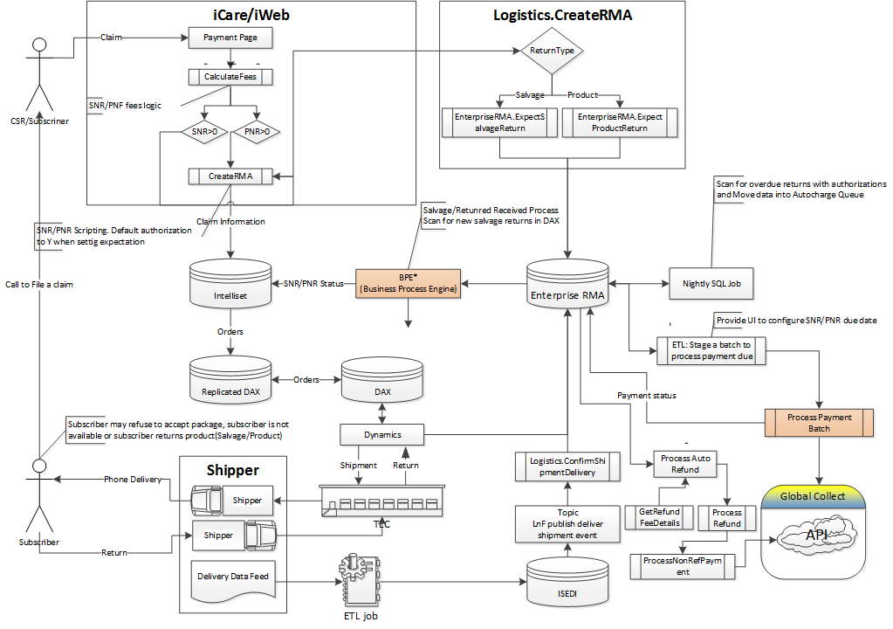

### SNR/PNR Automation Workflow – High-Level Architecture

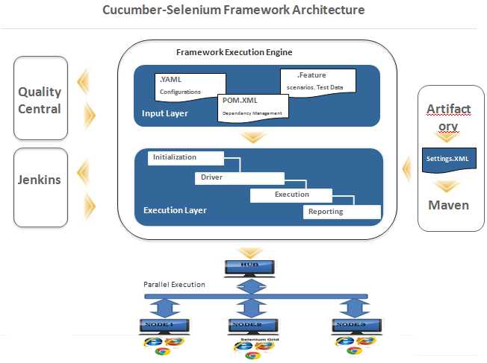

The SNR/PNR Automation Framework is a robust and unique automation framework that can be customized based on business requirements and processes and hence, it is better capable of balancing time and effort with performance and accuracy of test results generated.

Its capabilities include the following:

* Continuous integration with automation database for object repository, test scripts, and feature files management, and to manage code base dependencies, version control third-party tool, and behavior-driven development.
* Support for parallel execution on multiple browsers and system resource usage configurations for optimizing network loads
* Test data profiling to evaluate test data integrity
* Test data cleansing to meet prescribed standards for test data quality
* Apply processes such as requirement analysis, test data creation, test planning, execution, and reporting
* Easily move on freeware or cost effective tools
* No licensing fee. Can be used widely by SQA and Development team members on QA and Development integration environments
* Provide feasibility of writing our own Plug-ins
* Reduce hardware setup like Lab machines
* Usage on multiple environments
* Capability of standalone execution and Push results into any test management tool
* Ability to file multiple claims and initiate the SNR/PNR fees from one machine
* Support for multiple browser execution from a single machine
* Create automatic test script and test data file using the existing templates
* Supports distributed execution by executing test cases from multiple machines
* Standalone execution and bulk upload of results into Quality Center
* Prepare unattended test data that helps manual testers to use this data for executing test cases

# SNR/PNR Automation Framework

SNR/PNR Automation Framework is very flexible and customizable automation framework that is specifically designed for insurance domain. It is designed to work on inputs received from heterogeneous test data and feature files to function as a data integration layer across the organization. Behaviour Driven testing is an extension of Test-Driven Development. The major difference is that tests are written in plain descriptive method; tests are explained as behavior of application, and are more user focused using examples to clarify requirements. This difference brings in the need to have a language that can define, in an understandable format. Features of business-driven development for the automation framework are shifting from thinking in “tests” to thinking in “behavior”. It allows collaboration between Business stakeholders, Business Analysts, QA Team, and developers. The framework extends the TDD by utilizing plain English language that non-technical stakeholders can understand. The BDD framework such as Cucumber or JBehave is an enabler that acts as a “Bridge” between plain English language used by Business and Technical Language (Java) used by Technical staff.

The challenges faced by traditional business processes are as follows:

* Each client in the mobile insurance domain have their own business features in the mobile insurance applications. This required having different test data sets and business features in files and process of managing test data sets and these features that would results in different types of test repositories depending on requirements.
* Development is not time efficient due to the diversity in test data and business features. Any new development assignment requires a significant time to generate test data and gather requirements to reduce time and efforts, and deliver build for each sprint.
* The requirements were in the form of user stories and it becomes challenging to scale up the required test data and extract the business features and their impact on the existing features. Again these test data sets had limited capabilities to perform feature analysis, impact analysis, and create test data for critical features implementation.
* Test reporting automation required considerable efforts since the reports needed data from different applications and to be customized for different stakeholders.
* Business users had very limited capability or control over the kind of data that goes into the database, so they had to rely on the backend teams to get test data samples and follow tedious processes in case they require any test data to be updated within the automation database.
* Different automation testing tools offer automation testing, but no automation tool/framework offers a single solution for functions that could make test data management, Feature files management, repository creation, manage code base dependencies, automation database, administration, and reporting.

# Modules of the SNR/PNR Automation Framework

### Module 1: SNR/PNR Inventory Reconciliation

It automates the following functions:

* Validate calculated grace period as per configured conditions and values
* Validate the chargeable records based on grace period
* Verify warehouse system for device return
* Validate bank details/token and charge the record
* Validate the updated flags in integrated systems
* Validate invoice setup and invoice generation
* Validate the communication with customers using email

It eliminates this manual step:

* Manual validation of SNR/PNR Inventory Reconciliation

### Module 2: Inventory level management

It automates the following functions:

* Validate the number of devices in the inventory of a given warehouse as per market id. And expectation amount (this amount is derived by Asurion) depending on device rank, make, and model along with insurance fees, premium fees, program cost, and last claim history
* Validate the fees expectation in database

It eliminates this manual step:

* Manual validation of Inventory management

### Module 3: Auction Portal integration

It automates the following functions:

* Verify the device based on conditions specified by Asurion
* Verify list of devices to be salvaged or Auctioned
* Create and validate the devices in batches for Auction
* Validate the Failed/Successful records from the last batch and execute failed steps or re-execute required steps
* Create order in Auction portal for given batch
* Receive the acknowledgment of auctioned devices and update the inventory accordingly

It eliminates this manual step:

* Manual validation creating batches of salvage devices for auction

### Module 4: Billing Portal

It automates the following functions:

* Validate the records for customers who returned the device, but still SNR/PNR fees is charged to the customers
* Verify whether inventory systems are up to date
* Validate the calculated refund amount
* Validate the refund amount processing
* Update billing system

It eliminates this manual step:

* Manual validation inventory and returns
* Manual validation for refund amount processing

### Module 5: Integration with Legacy Systems

It automates the following functions:

* Verify the salvage expectation is correctly set or not
* Validate the integration with third-party shipper for all shipment-related tasks, tracking of shipment, and know shipping schedule
* Validate the integration with inventory system to maintain stock of devices including make and models, utilize systems data for fees calculation
* Validate the integration with Payment systems for payment collection in that Auto Pay job

It eliminates this manual step:

* Manual validation of Integration with Legacy System

### Module 6: Communication Gateway

It automates the following functions:

* Validate the Email notification functionality including carrier-specific templates
* Validate the Email notification by integrating third-party APIs

It eliminates this manual step:

* Manual validation of Communication with customer for device shipment, payment due, and device expectation

### Module 7: Supply Fee Report

It automates the following functions:

* Validate the SNR/PNR Charged Customers with periodic criteria selection
* Validate the Pending chargeable records on monthly basis
* Validate the Device expected records, Summary of transactions, Fraud Detection

It eliminates this manual step:

* Manual validation of Supply Fee reporting

# Case Study

### Context

A major insurance client has diverse features arising from different departments using different processes, but coordinating with one another. For example, the subscriber of an insurance client wants to file a claim on damaged mobile device, then the subscriber has to go through all the modules and provide the necessary information during the claim processing such as Subscriber information, Peril information or damaged device information, Claimed equipment, replacement equipment, Shipping information, Payment information, and finally the claim completion. As soon as the claim is completed, the deductible is charged to the customer and the Salvage Non-Return Fees and Product Non-Return (SNR and PNR) fees is applied, if the subscriber is not returning the salvage device within stipulated timeframe.

### Objectives

It is proposed to implement the SNR/PNR Automation Framework that will enable BDD, feature-based automation test execution to reduce the manual efforts, and validate all the features, and address issues or defects in SNR/PNR fees charging and SNR/PNR Inventory Reconciliation. The automation framework will also generate test repositories for business users to serve as a single point of reference. The automation framework should generate a concise test reports and defect reports so that corrective actions can be taken to resolve the issues.

This automation framework should have the capabilities to be modeled as per the business process and new implementation of features, so that it provides solutions to validate the changing business requirements.

### Solution

The SNR/PNR Automation Framework will leverage its integration and capabilities to combine the features into test repository and automation database architecture for archiving the test data and comparing it with the expected results during the validation of the features. The business users will be assisting the Synechron team in building a feature repository that will serve as a reference data set through the organization. This also required creating test scripts, adding objects into object repository, adding keywords. Automation database stores objects repository, test scripts in the XML format, database queries, stored procedures, and feature files. The automation framework manages the code base dependencies, version control across automation team, and behavior driven development. Selenium test engine runs the test scripts according to business workflow and fetches the required details from automation database and the reporting tool generates the logs through test management tool and generates a test report and defect report.

The analysis of failed test scripts carried out on different test data parameters and compares with the expected results according to features. Based on this, the automation framework was designed to give customers an insight into their SNR/PNR fees processing, following which the manual test execution reduced and reliability improved.

### Salient Features

* Detailed analysis of functional and technical dependencies of automation framework and their integration
* Analysis of the existing system for analyzing bottlenecks and mitigating them through the SNR/PNR automation framework
* Business challenges faced currently and the target state intended
* Migration, training plan, and resource identification post implementing SNR/PNR Automation Framework
* Design of automation database including the object repository, feature files, and test scripts
* Testing techniques such as System Testing, Regression Testing, and Feature-based testing

### Conclusion

The SNR/PNR Automation Framework has been quite effective in modeling requirements and business processes through a customizable platform. The Return on Investment (ROI) for the SNR/PNR Automation Framework implementation is quite promising and is in line with business expectations. The automation framework is offered as a service and will continue to be modeled and implemented for multiple insurance clients.

# About Synechron

Synechron, Inc. is a wholly owned subsidiary of Synechron Holdings, Ins.; a British Virgin Islands International Business Company. Synechron, Inc. US was founded in 2005 and is headquartered in Piscataway, New Jersey. Synechron is one of the fastest growing IT companies, specializes in Insurance, Capital Markets, Mortgage Banking, Energy and Commodities and Digital Media & Technology space. The company offers information technology strategy and architecture, application development and maintenance, mobile application development, business intelligence and data warehousing, cloud computing, QA service offerings, business process management (BPM), remote infrastructure management, and business process outsourcing Services. It has significant presence in the US, Canada, UK, the Netherlands, Ireland, UAE, Singapore, Hong Kong, Japan, and state- of- the art Development Centers based in Pune, India. Synechron currently employs approximately 5000+professionals globally.

# About the authors

Mr. Shardul Kaley ([shardul.kaley@synechron.com](mailto:shardul.kaleyl@synechron.com)) is Assistant Manager – Quality Control automation testing expert with deep technical and architectural knowledge in SNR/PNR Automation Framework development, and an implementation expert for the Insurance domain.